**Assignment 7: A review of chapters 1 to 5**

**CIS 310 FALL 2019**

**Sohal Patel**

**Please do your best to answer the following six questions, using Visio or Lucid Chart.**

**1. Typically, a patient staying in a hospital receives medications that have been ordered by a particular doctor. Because the patient often receives several medications per day, there is a 1:M relationship between PATIENT and ORDER. Similarly, each order can include several medications, creating a 1:M relationship between ORDER and MEDICATION.**

**a. Identify the business rules for PATIENT, ORDER, and MEDICATION.**

1. The business rules in the PATIENT are:

* A patient can have many orders composed for that person.
* Every order is composed for a solitary patient.

1. The business rules in the ORDER are:

* Every order can endorse numerous medications.
* Every medication can be endorsed in numerous orders.

1. The business rules in the MEDICATION are:

* Each medication can be prescribed in many orders.
* Each order can prescribe many medications.

**b. Create a Crow's Foot ERD that depicts a relational database model to capture these business rules.**



**2. United Broke Artists (UBA) is a broker for not-so-famous painters. UBA maintains a small network database to track painters, paintings, and galleries. A painting is painted by a particular artist, and that painting is exhibited in a particular gallery. A gallery can exhibit many paintings, but each painting can be exhibited in only one gallery. Similarly, a painting is painted by a single painter, but each painter can paint many paintings. Using PAINTER, PAINTING, and GALLERY, in terms of a relational database:**

1. **What tables would you create, and what would the table components be? Identify each table with attributes**

|  |  |  |
| --- | --- | --- |
| Table: PAINTER | Table: PAINTING | Table: GALLERY |
| PAINTER_ID | **PAINTING_ID** | **GAL_ID** |
| PAINTER_FNAME | **PAINTING_TITLE** | **GAL_NAME** |
| PAINTER_INIT | **PAINTING_AGE_DATE** | **GAL_LOCATION** |
| PAINTER_LNAME | **PAINTER_ID** | **GAL_SIZE** |
| PAINTING_ID | **GAL_ID** | **GAL_WEBSITE** |

1. **Identify applicable business rules for each entities (tables)**

* A painter can paint many paintings.
* Each painting is painted by only one painter.
* A gallery can exhibit many paintings.
* A painter can exhibit paintings at more than one gallery at a time.
* Each painting is exhibit in only one gallery.

** c. Show the relationships in a Crow’s Foot diagram**

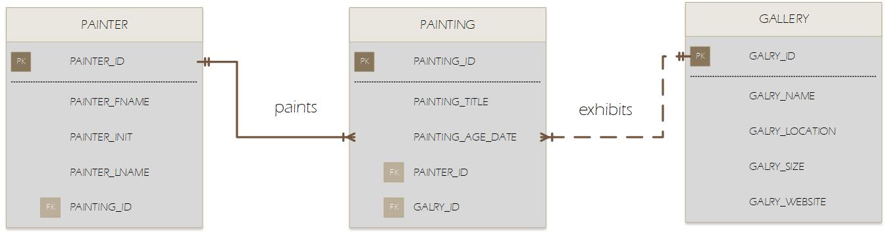**3. Using the ERD you created from Problem 2, create the relational diagram. (Create an appropriate collection of attributes for each of the entities. Make sure you use the appropriate naming conventions to name the attributes.)**

**4. Convert the ERD from Problem 1 into the corresponding UML class diagram.**

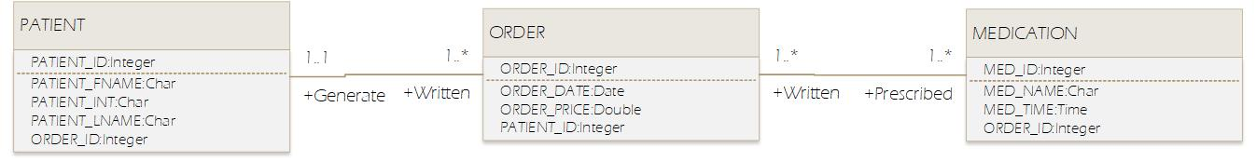

**5. Identify the business rules from the depicted relationships in the Crow’s Foot ERD shown in Figure 5.1**

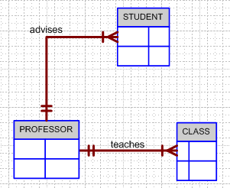

**Figure 5.1 The Crow’s Foot ERD for Problem 5**

**The Business Rules:**

* Each student is advised by one professor.
* A professor can advise many students.
* Each class is taught by one professor.
* A professor can teach many classes.

**6. Create a Crow’s Foot ERD to include the following business rules for the ProdCo company:**

1. **Each sales representative writes many invoices.**
2. **Each invoice is written by one sales representative.**
3. **Each sales representative is assigned to one department.**
4. **Each department has many sales representatives.**
5. **Each customer can generate many invoices.**
6. 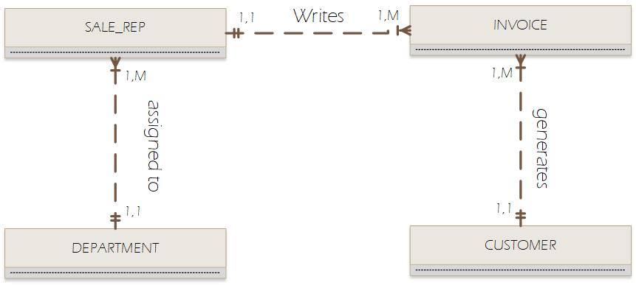**Each invoice is generated by one customer**

**7. What is normalization and why it’s important?**

Normalization is a procedure for assessing and amending table structures to limit information redundancies, in this way decreasing the probability of information inconsistencies. The normalization procedure includes relegating ascribes to tables dependent on the ideas of assurance and useful reliance. The principle objective of normalization is to wipe out information oddities by disposing of pointless or undesirable information redundancies. Normalization utilizes the idea of useful conditions to distinguish which quality (or set of attributes) decides different attributes.

1. **describe the three forms**

|  |  |
| --- | --- |
| Normal Form | Characteristic |
| First normal form (1NF) | Table format, no repeating groups, and PK identified. |
| Second normal form (2NF) | 1NF and no partial dependencies. |
| Third normal form (3NF) | 2NF and no transitive dependencies |

1. **describe the data modeling checklist**

The data-modeling checklist provides a way for the designer to check that the ERD meets a set of minimum requirements.

* **Data modeling checklist: Business rules:** Appropriately report and confirm business rules with end clients. Guarantee rules are composed unequivocally; distinguish traits, connections, and requirements. Distinguish wellspring of business rules; defended, dated, and closed down by a position.
* **Data modeling checklist: relationships:** Distinguish relationship members. Characterize support, availability, and report cardinality.